**Problem based component 5 – Alex Bartella 400308868**

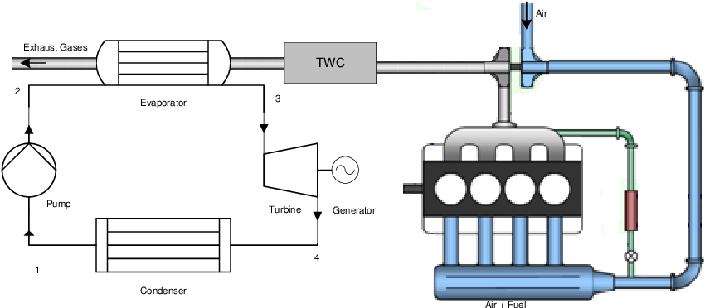Recently, the possibility of recovering waste heat from automobiles using a Rankine cycle has been explored to generate power in hybrid cars. The process involves using exhaust gases in a heat exchanger in place the boiler in the Rankine cycle, producing work using the turbine, which generates power to be used by the electrical components of the hybrid engine system.

In this case, the exhaust gases (cp=5.25 kJ/kg*K) enter the heat exchanger at 602.66 deg C, and exit at 90 deg C. The condenser operates at 25 deg C. Assume an ideal Rankine cycle.

1. Find the specific heat supplied in the boiler.
2. Find the specific work produced by the turbine.
3. Find the efficiency of the cycle.